Espresso House
https://www.dn.no/smak/oppkjop/uteliv/kaffe/nordmenn-selger-espresso-house/1-1-5388603

https://sv.wikipedia.org/wiki/JAB_Holding_Company
https://www.jabholco.com/

JAB Holding Company S.a.r.l

What Is JAB? Owner of Panera, Snapple and Krispy Kreme Faces Its Nazi Past
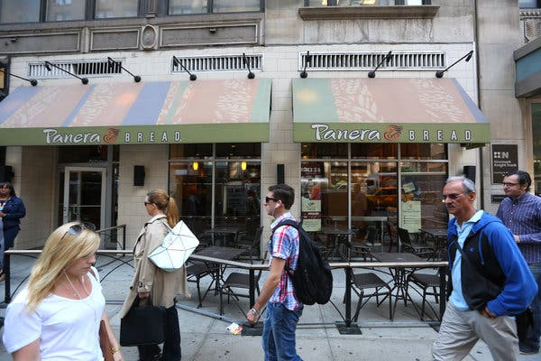
Image
A Panera Bread store in New York. The restaurant chain is among the companies that make up the German conglomerate JAB Holding’s empire of food and beverage businesses.CreditCreditChang W. Lee/The New York Times
By Michael J. de la Merced
- June 14, 2019

The average person probably hasn’t heard of JAB Holding. The same can’t be said for the vast empire of brands — a stable that includes Keurig coffee pods, Dr Pepper, Snapple, Einstein Bros. Bagels and Krispy Kreme doughnuts — it amassed in years of deal-making. Here’s how the conglomerate, whose controlling family is now grappling with its Nazi past, flourished.
[Read our article about the Nazi past behind JAB Holding, and the company’s efforts to atone.]

The beginning
JAB grew out of the personal fortune of the Reimann family, which founded the German chemical company Benckiser. (The company was previously known as Joh. A. Benckiser, for one of the family patriarchs.) Benckiser eventually merged with Reckitt & Colman of Britain to become Reckitt Benckiser, whose holdings include Durex condoms, Lysol cleaner and Clearasil.

Cosmetics
In 1992, JAB bought control of Coty, a cosmetics maker, from Pfizer. Since then, it has become an industry giant, assembling an array of celebrity-backed fragrances, as well as those from well-known brands like Calvin Klein.
The company gained a new level of prominence in 2012 when it unsuccessfully bid nearly $11 billion for Avon Products, a better-known but struggling rival.

Subscribe to With Interest
Catch up and prep for the week ahead with this newsletter of the most important business insights, delivered Sundays.
SIGN UP
ADVERTISEMENT

https://www.dailymail.co.uk/news/article-6171977/Nazi-slavery-past-family-buying-Pret-Manger-founded-Jewish-businessman-1-5billion.html

https://www.forbes.com/sites/maddieberg/2019/04/02/more-than-a-dozen-of-europes-wealthiest-billionaires-and-their-families-had-nazi-ties/#3092f9316015

Co
Avsløringer fra Sverige og Norge viser groteske arbeidsforhold i kaffebarene Espresso House.

Typisk for

